SOCIAL MOOD MATCHER
AI-Powered Social Media Caption & Hashtag Generator
Project Description
Creating attractive social media posts with suitable captions and trending hashtags can be difficult and time-consuming for content creators, marketers, and social media managers. Many users spend a lot of time thinking about the right caption, searching for relevant hashtags, and making sure the content fits the character limits of different social media platforms.
The Social Mood Matcher system is designed to solve this problem by using artificial intelligence to automatically generate captions and hashtags based on the mood of an image. The system analyzes uploaded images using models such as BLIP for image captioning and DistilBERT for sentiment analysis to understand the visual content and emotional tone of the image. For better caption quality, the platform can also use Google Gemini 2.5 Flash as an optional enhancement.
Based on the detected mood and context, the platform generates captions in different styles such as casual, aesthetic, professional, and playful. It also suggests relevant and trending hashtags grouped by category and sentiment. Additionally, the system ensures that the generated captions and hashtags follow the character limits of major social media platforms including Twitter/X (280 characters), Instagram (2,200 characters), and Facebook (63,206 characters). By automating caption creation and hashtag selection, Social Mood Matcher makes social media content creation faster, easier, and more efficient.
Use Case Scenarios
Scenario 1: Food Photography with Mood Detection
A food blogger uploads a photo of a homemade soup placed on a wooden table. The system analyzes the image using the BLIP model to understand the visual content and uses DistilBERT to identify the sentiment of the image, such as cozy and warm.

Based on the detected mood, the system generates a caption in the selected style. For example:
"Nothing beats a warm bowl of homemade soup on a chilly evening."
The platform also suggests suitable hashtags such as:
#FoodPhotography #CozyVibes #Homemade #ComfortFood
The generated caption and hashtags are automatically formatted according to the selected social media platform, ensuring the content fits within the Twitter/X character limit of 280 characters.
Scenario 2: Travel Content with Multi-Style Options
A travel influencer uploads a sunset beach image. The system analyzes the image and detects emotions such as peaceful and aesthetic.
When the Gemini-enhanced mode is enabled, the system generates multiple caption styles, allowing the user to choose the most suitable one.
Example caption styles:
• Aesthetic: “Golden hour whispers stories only the ocean knows.”
• Punchy: “Sunset state of mind.”
• Casual: “Beach sunsets hit different.”
Along with the caption, the system suggests trending hashtags like:
#TravelPhotography #SunsetVibes #BeachLife #GoldenHour
The platform also optimizes the content to ensure it fits within Instagram’s formatting and character limits.
Scenario 3: Brand Content with Character Limiting
A marketing professional uploads a product image for a luxury brand. The system analyzes the image and detects sentiments such as luxury and elegance.
Based on this analysis, the platform generates a professional-style caption without emojis and recommends premium hashtags such as:
#LuxuryLifestyle #Premium #Elegance
If the total length of the caption and hashtags exceeds the Twitter/X character limit, the system automatically shortens the hashtag list while keeping the full caption intact. This ensures that the main message of the post is preserved while still fitting within the platform’s character restrictions.
Architecture Overview
Social Mood Matcher is a modular AI-based system designed to generate captions and hashtags for social media posts based on the mood of an uploaded image. The platform combines a user-friendly interface with multiple AI models to analyze images and generate relevant content automatically.
Main Components of the Architecture:
• Frontend (Streamlit) – Provides the user interface where users upload images, select caption styles, and view generated captions and hashtags.
• Image Captioning (BLIP Model) – Analyzes the uploaded image and generates a textual description of the visual content.
• Sentiment Analysis (DistilBERT) – Identifies the emotional tone or mood of the image such as happy, calm, aesthetic, or energetic.
• Gemini 2.5 Flash (Optional) – Enhances caption generation quality and provides more creative and context-aware outputs.
These components work together to analyze images, detect mood, and generate platform-ready captions and hashtags efficiently

Core Technologies
• Streamlit – Used as the frontend framework to build an interactive user interface and enable real-time caption and hashtag generation.
• BLIP (Salesforce) – An image captioning model that analyzes uploaded images and generates a description of the visual content.
• DistilBERT – A lightweight NLP model used to perform sentiment analysis and detect the mood present in the image.
• Gemini 2.5 Flash (Optional) – An advanced AI model that improves caption quality and provides better contextual understanding of images.
• Python-DOCX – Allows the application to export generated captions and hashtags into Word document format.
• ReportLab – Used for generating PDF files with structured and professional formatting.
• Pillow (PIL) – A Python library used for image processing tasks such as resizing, loading, and manipulating images.
• Transformers (Hugging Face) – Provides tools and pretrained models required for integrating AI models into the application.
Component | Description
Frontend UI | A Streamlit-based user interface that allows users to upload images, choose caption styles, select social media platforms, and view generated captions and hashtags in real time. It also displays sentiment indicators and export options.
Image Sentiment Detector | Processes uploaded images using BLIP to understand the scene and DistilBERT to classify the emotional tone. It identifies moods such as happy, calm, cozy, aesthetic, adventurous, romantic, and nostalgic.
Caption Generator | Generates captions based on the detected mood, selected caption style (casual, aesthetic, professional, playful), and image category such as food, travel, nature, or lifestyle. It can use predefined templates or Gemini API for enhanced results.
Hashtag Engine | Suggests trending hashtags organized by category and sentiment. The engine prioritizes hashtags based on relevance and ensures compatibility with different social media platforms.
Character Limiter | Ensures that the generated captions and hashtags fit within platform character limits (Twitter/X, Instagram, Facebook) by intelligently shortening hashtags if necessary.
Gemini AI Layer (Optional) | Uses Gemini 2.5 Flash to improve caption generation quality, provide multiple caption variations, and enhance contextual understanding of images.

System Requirements
- Python 3.10 or above – Install Python from the official website: https://python.org
- Streamlit Framework – Used to develop the interactive web interface. Documentation is available at: https://docs.streamlit.io
- Google AI Studio Account (Optional) – Required to access the Gemini API. It can be created at: https://makersuite.google.com
- Required Python Libraries – All necessary libraries are listed in the requirements.txt file and can be installed using pip.
- Hardware Requirement – At least 4GB RAM is recommended for running AI models and processing images.
- Internet Connectivity – Required for downloading models and using optional Gemini API features.

Project Development Process
The Social Mood Matcher project is developed through a structured five-stage process, starting from the initial environment setup and continuing until testing and deployment preparation. Each stage builds on the previous one to ensure the application is fully functional and ready for use.

1. Environment Setup and Configuration
• Create the project folder structure and organize necessary files
• Configure environment variables and API keys
• Install all required dependencies and verify successful installation
• Test connectivity of AI models (local models and optional Gemini API)

2. Core Services Development
• Develop the Image Sentiment Detector service
• Build the Caption Generator supporting multiple styles
• Implement the Hashtag Engine using trending hashtags
• Develop the Character Limiter to match platform restrictions
• Integrate the optional Gemini AI service for improved results

3. Backend Implementation
• Design a modular backend architecture within the Streamlit framework
• Create utility functions for image processing and text handling
• Implement session state management
• Add error handling and logging mechanisms

4. User Interface Development
• Design a responsive Streamlit-based interface
• Implement image upload and preview features
• Create sidebar controls for selecting style and platform
• Add tab-based result display
• Enable export and download functionality

5. Testing and Optimization
• Perform testing across all major features
• Optimize AI model performance and caching mechanisms
• Verify character limit handling for different platforms
• Test compatibility across multiple social media platforms
• Prepare configuration for deployment

MILESTONE 1: Development Environment Setup
In this initial stage, the goal is to prepare the development environment and configure all required tools, libraries, and AI services needed to build the Social Mood Matcher application.

Activity 1.1: Project Structure Setup
Create the main project directory and organize the folder structure properly. This includes separate folders for services, utilities, configuration files, and testing modules to ensure the project remains clean and well structured.
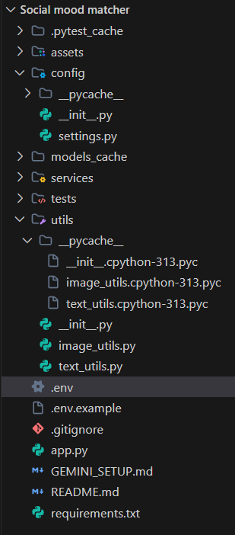

Activity 1.2: Installing Required Dependencies
Install all the necessary Python packages using the pip package manager. The requirements.txt file contains the list of libraries needed for the project, including Streamlit, Transformers, PyTorch, Pillow, and optional support for the Gemini API.

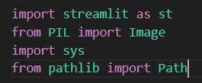

Activity 1.3: Environment Variable Configuration
Create and configure the .env file to store important project settings. This file includes configurations such as the optional Gemini API key, model cache directory, and debugging options required for running the application.

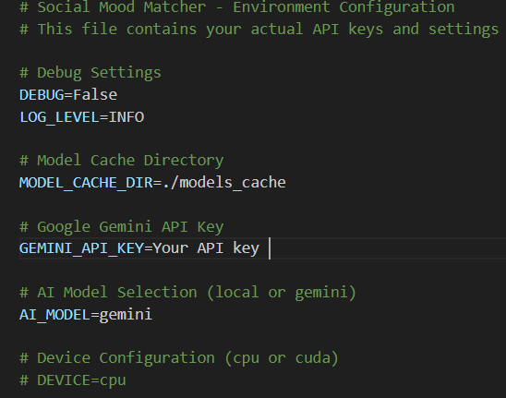

Activity 1.4: Gemini API Setup (Optional)
- Open Google AI Studio: https://makersuite.google.com/app/apikey
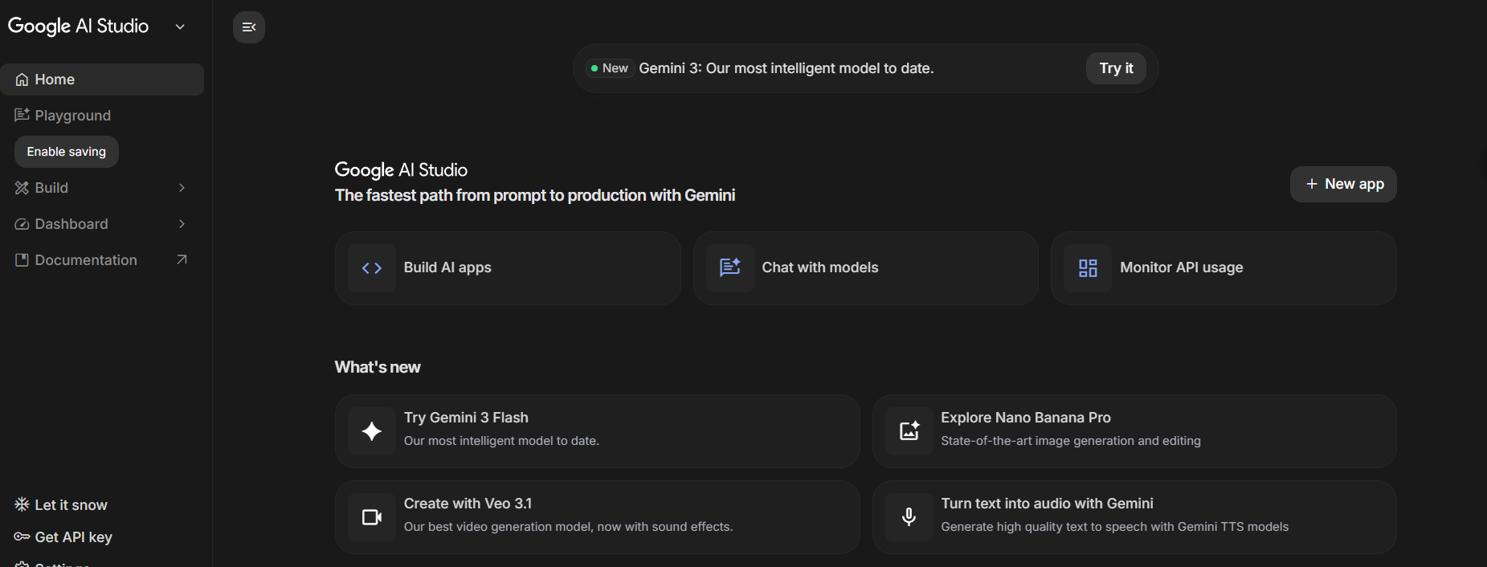
- Sign in using your Google account
- Select “Create API Key” and copy the generated key
- Add the API key to the .env configuration file:
GEMINI_API_KEY=your_key_here

- Enable Gemini mode by adding the following in the .env file:
AI_MODEL=gemini
- Install the google-generativeai Python package (already included in the requirements.txt file)

MILESTONE 2: Core Service Development
This milestone focuses on developing the main AI-based services that act as the foundation of the Social Mood Matcher system. Each service is implemented as a separate and testable module so that it can be easily maintained and integrated within the application.

Activity 2.1: Image Sentiment Detection Service
Develop the image_sentiment.py module which utilizes BLIP for image caption generation and DistilBERT for sentiment analysis. This module serves as the first stage in the content generation workflow by analyzing the uploaded image and identifying its mood and context.

Key Features
• Load and cache the BLIP image captioning model
• Load and cache the DistilBERT sentiment analysis model
• Process uploaded images to extract descriptive captions
• Analyze the sentiment based on image captions and visual elements
• Categorize the mood into multiple classes such as happy, cozy, aesthetic, calm, etc.
• Identify image categories like food, travel, nature, and lifestyle
• Provide confidence scores for each detected sentiment

Activity 2.2: Caption Generation Service
Develop the caption_generator.py module responsible for generating engaging captions based on the detected sentiment, selected caption style, and the context of the uploaded image. This service ensures that captions match the mood and theme of the image.
Supported Styles:
Style | Description | Emoji Usage
Casual | Friendly, relaxed tone | Moderate (2-3)
Aesthetic | Poetic, artistic language | Minimal (0-1)
Professional | Polished, informative | None
Playful | Fun, energetic tone | High (3-5)

Activity 2.3: Hashtag Engine Service
Develop the hashtag_engine.py module that generates curated and trending hashtags based on image category and detected sentiment. This service includes a collection of popular hashtags to improve social media engagement.
Hashtag Categories
• Food: #FoodPhotography, #Foodie, #InstaFood, #FoodLover, #Delicious
• Travel: #TravelPhotography, #Wanderlust, #TravelGram, #Explore, #Adventure
• Nature: #NaturePhotography, #NatureLover, #Landscape, #Scenic, #OutdoorLife
• Lifestyle: #LifestylePhotography, #DailyLife, #Moments, #Inspiration, #Aesthetic

Activity 2.4: Character Limiting Service
Develop the character_limiter.py module that ensures all generated captions and hashtags remain within the character limits defined by different social media platforms. The service also applies smart truncation techniques to preserve the main message of the caption.
Platform | Character Limit | Truncation Strategy
Twitter/X | 280 | Caption is prioritized and hashtags are shortened if necessary
Instagram | 2,200 | Usually not required as most content fits within the limit
Facebook | 63,206 | Character limiting is rarely needed

Activity 2.5: Optional Gemini AI Integration
Develop the gemini_service.py module for users who want advanced AI-powered features. This optional service improves caption generation quality, provides multiple caption variations, and enhances image understanding.
Key Features
• Improved sentiment detection with greater accuracy
• Generates multiple caption styles such as aesthetic, punchy, and descriptive
• Visual intelligence capabilities including detection of dominant colors and objects
• Provides composition suggestions to improve photography
• Produces more creative and context-aware captions

MILESTONE 3: Backend System Implementation
This milestone focuses on integrating all the developed services into a unified backend structure within the Streamlit application. The goal is to ensure smooth interaction between modules while maintaining proper session state management, error handling, and efficient caching mechanisms for better application performance.
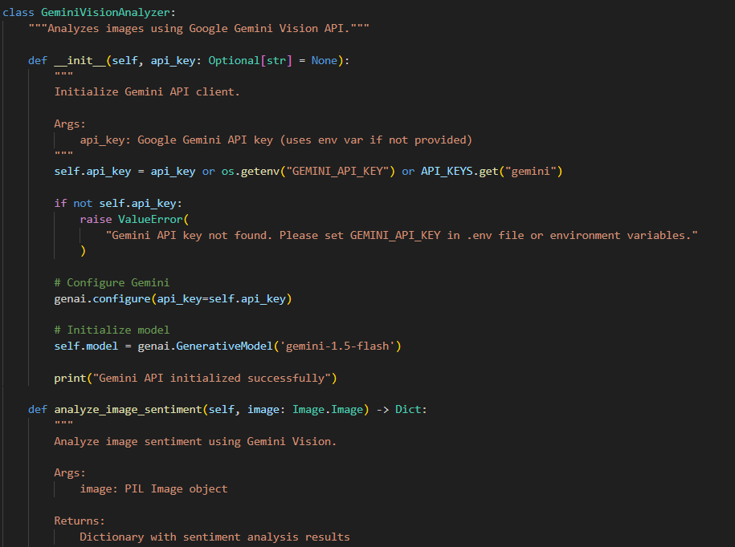

Activity 3.1: Session State Management
Implement proper Streamlit session state initialization to maintain user selections, generated outputs, and application state during page reruns. This helps preserve previously generated results and improves the user experience.
• generated_caption – Stores the currently generated caption
• generated_hashtags – Stores the list of generated hashtags
• sentiment_result – Contains detected sentiment details and related metadata
• caption_variants – Stores multiple caption options generated in Gemini mode
• visual_analysis – Holds visual intelligence information from Gemini analysis
• history – Maintains a record of previously generated results
• use_gemini – Indicates whether Gemini mode or local models are being used
• gemini_analyzer – Stores the cached Gemini service instance

Activity 3.2: Service Initialization and Model Caching
Use Streamlit’s @st.cache_resource decorator to load AI models only once and reuse them across application sessions. This approach improves system performance by preventing repeated loading of large models.
• ImageSentimentDetector – Loads the BLIP image captioning model and DistilBERT sentiment analysis model (approximately 2GB)
• CaptionGenerator – Handles caption generation using predefined templates and style rules
• HashtagEngine – Manages the curated hashtag database and retrieval system
• CharacterLimiter – Applies platform-specific character limit rules and truncation logic
• GeminiAnalyzer (Optional) – Connects to the Gemini API for enhanced caption generation and analysis
Activity 3.3: Error Handling and Validation
Implement effective error handling for file uploads, AI model processing, and API interactions. The system should display clear error messages and apply fallback mechanisms to maintain smooth operation.
- Invalid file format – Display supported image formats such as JPG, PNG, and WEBP.
- File size too large – Notify the user if the uploaded image exceeds the maximum size limit (10MB).
- Model loading failure – Provide a retry option or load previously cached models if available.
- Gemini API error – Automatically switch to local AI models when the Gemini API fails.
- Empty caption generation – Retry the generation process with adjusted parameters.

Activity 3.4: Image and Text Processing Utilities
Develop utility functions inside the utils/ directory to handle common image and text processing tasks used across the application.
• image_utils.py – Contains functions such as validate_image(), resize_image(), preprocess_for_model(), and create_thumbnail() for handling image validation and preprocessing.
• text_utils.py – Includes functions like clean_text(), format_hashtags(), truncate_text(), and smart_truncate_with_hashtags() for managing caption formatting and hashtag processing.

MILESTONE 4: User Interface Development
This milestone focuses on designing an intuitive and visually appealing Streamlit-based interface. The interface should provide responsive design, easy navigation, and real-time feedback while generating captions and hashtags.

Activity 4.1: Main Interface Layout Design
Design a two-column layout where the image upload section appears on the left and the generated results are displayed on the right. Custom CSS styling is used to improve the visual appearance of the interface.
• Header section with a gradient title and subtitle
• Sidebar panel for settings such as caption style, platform selection, hashtag count, and Gemini toggle
• Left column – Image upload area with preview functionality
• Right column – Tab-based results including Content, Visual Pro, and History
• Custom color theme aligned with the project branding (purple gradient)
• Responsive layout optimized for both mobile and desktop screens

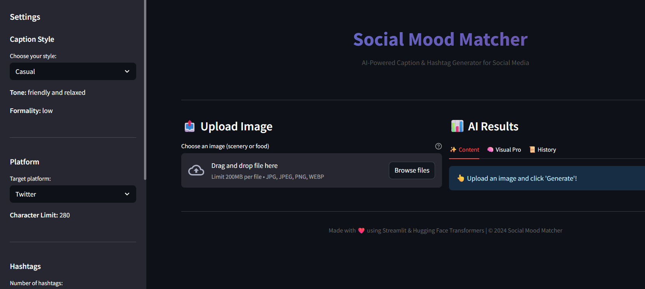

Activity 4.2: Sidebar Control Panel
Develop a sidebar section that allows users to customize different parameters for caption and hashtag generation.
• Caption Style – Choose from styles such as Casual, Aesthetic, Professional, or Playful
• Platform Selection – Select the target platform: Twitter/X, Instagram, or Facebook
• Hashtag Count – Adjust the number of hashtags using a slider ranging from 3 to 15
• Gemini API Option – Toggle between enhanced Gemini mode and local AI model processing
• About Section – Displays a brief description of the application along with its main features.
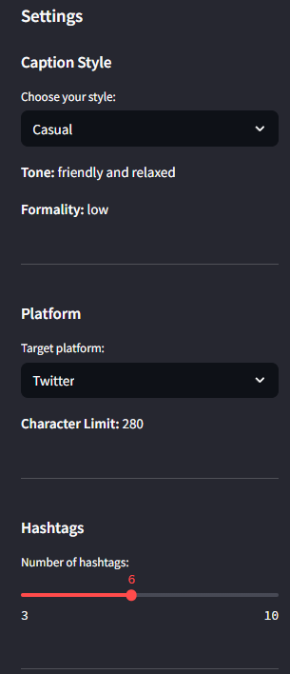

Activity 4.3: Results Display Interface
Develop a tab-based interface to present different types of generated results in an organized manner.
• Content Tab – Displays the sentiment badge, caption variant selector (Gemini mode), generated caption, suggested hashtags, and character count.
• Visual Pro Tab – Shows visual intelligence details (Gemini mode only) such as dominant colors, detected objects, and composition suggestions.
• History Tab – Displays the last five generated results along with their detected sentiment and timestamp.

Activity 4.4: Export Feature
Implement a download option that allows users to export the generated content as a text file. The exported file includes the caption and hashtags formatted properly for quick copy-paste and use on social media platforms.

MILESTONE 5: Testing and Performance Optimization
This milestone focuses on thoroughly testing the application to ensure reliability, accuracy, and overall system performance. It includes different testing approaches such as unit testing, integration testing, and performance optimization to make sure the application functions correctly and efficiently.

Activity 5.1: Unit Testing
Test individual components of the system using the pytest framework. Each module should be tested to ensure proper functionality and comprehensive test coverage.
• TestImageProcessor – Tests image validation, resizing, and preprocessing functions
• TestTextProcessor – Tests text cleaning, hashtag formatting, and truncation operations
• TestCaptionGenerator – Verifies caption generation across different styles and sentiment categories
• TestHashtagEngine – Tests hashtag retrieval, filtering, and priority-based selection
• TestCharacterLimiter – Validates platform character limits, smart truncation logic, and edge cases

Activity 5.2: Integration Testing
Test the complete workflow of the system from image upload to the final generation of captions and hashtags.
• Processing pipeline: Image upload → Sentiment detection → Caption generation → Hashtag retrieval → Character limiting
• Test the system using different image categories such as food, travel, nature, and lifestyle
• Verify that all caption styles generate appropriate and relevant outputs
• Ensure that the generated content respects character limits for each social media platform
• Test the fallback mechanism to confirm the system switches to local models if the Gemini API fails

Activity 5.3: Performance Optimization
Improve the application’s performance to ensure faster response times and a smoother user experience.
• Use @st.cache_resource to load AI models once and reuse them, preventing repeated loading
• Resize images before model inference to reduce processing time
• Display loading indicators during AI operations to enhance user experience
• Cache the Gemini API client to avoid repeated initialization
• Optimize session state updates to reduce unnecessary reruns in the application

Performance Metrics (Expected)
Operation | First Run | Subsequent Runs
Model Loading | 30-60 seconds | Instant (cached)
Image Analysis | 3-5 seconds | 2-3 seconds
Caption Generation | 1-2 seconds | 1-2 seconds
Gemini API Call | 2-4 seconds | 2-4 seconds
Total (Local Mode) | ~35-70 sec first | ~5-8 sec
Total (Gemini Mode) | ~5-10 sec | ~4-6 sec

Deployment Guide
The Social Mood Matcher application can be deployed on different cloud platforms. This section explains deployment using Streamlit Cloud and other cloud providers such as AWS, Google Cloud Platform (GCP), and Microsoft Azure.

Option 1: Streamlit Cloud (Recommended)
- Upload the project code to a GitHub repository.
- Go to https://share.streamlit.io and sign in to your account.
- Click “New App” and choose the repository containing your project.
- Set the main application file (e.g., app.py) and select the Python version (3.10).
- Add required secrets by navigating to Advanced Settings → Secrets.
- Deploy the application and wait for the build process to complete (approximately 5 minutes).

Option 2: Cloud Platforms (AWS / GCP / Azure)
The application can also be deployed on major cloud platforms for better scalability and reliability. Managed container services such as AWS ECS, Google Cloud Run, or Azure Container Instances can be used to host the application.

Troubleshooting Guide
Issue: Models Not Loading
• Check the internet connection during the first-time model download
• Ensure the MODEL_CACHE_DIR has proper write permissions
• Verify that sufficient disk space is available (approximately 2GB)
• Try clearing the model cache using: rm -rf models_cache/

Issue: Gemini API Errors
• Confirm that the API key is correctly added in the .env file
• Check the API usage quota in Google AI Studio
• Ensure the google-generativeai package is properly installed
• The system will automatically switch to local AI models if the API fails

Issue: Session State Problems
• Clear the browser cache and reload the application page
• Verify proper initialization of the Streamlit session state
• Ensure all required session variables are defined

Issue: Character Limit Not Working
• Confirm that the selected platform matches the expected character limit
• Check the logic of the smart_truncate_with_hashtags() function
• Test the system with different caption and hashtag combinations

Issue: Image Upload Failures
• Ensure the image format is supported (JPG, PNG, WEBP)
• Verify the file size is below 10MB
• Check that the uploaded image is not corrupted
• Try uploading another image or resize the image before uploading

Conclusion
Social Mood Matcher improves the process of creating social media content by providing intelligent, AI-powered captions and hashtag suggestions based on the mood and context of an uploaded image. By integrating BLIP for image understanding, DistilBERT for sentiment analysis, and the optional Gemini 2.5 Flash for enhanced caption quality, the system can analyze visual content and generate engaging posts that are optimized for different social media platforms.
The platform is designed with a modular architecture that combines AI-based content generation with a responsive and user-friendly interface. The Streamlit frontend enables easy interaction for users, while the backend efficiently manages model processing, error handling, and performance optimization.
Overall, the system helps content creators save time while producing high-quality captions and hashtags. From detecting image sentiment to applying platform-specific character limits, Social Mood Matcher works as an intelligent assistant that simplifies social media content creation while maintaining creativity and engagement.
Future Improvements
• Add support for video content analysis in addition to images
• Enable multi-language caption generation for a wider audience
• Implement A/B testing to compare different caption variations
• Integrate social media analytics for performance insights
• Support batch processing to analyze multiple images at once
• Provide custom hashtag training based on user preferences and trends
• Enable direct posting to social media platforms from the application
• Add brand voice customization for businesses and content creators
• Introduce collaboration features for teams managing social media accounts

